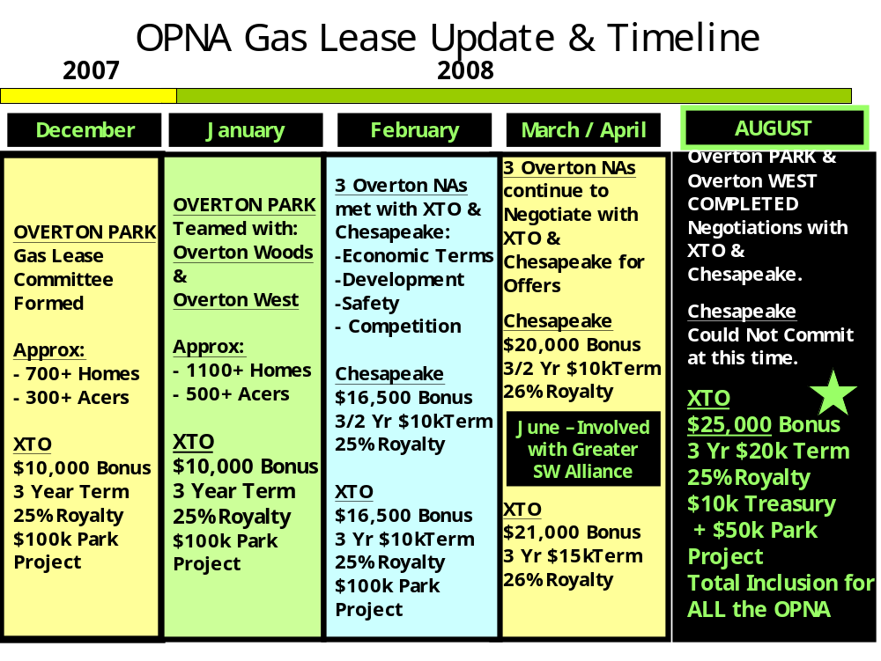

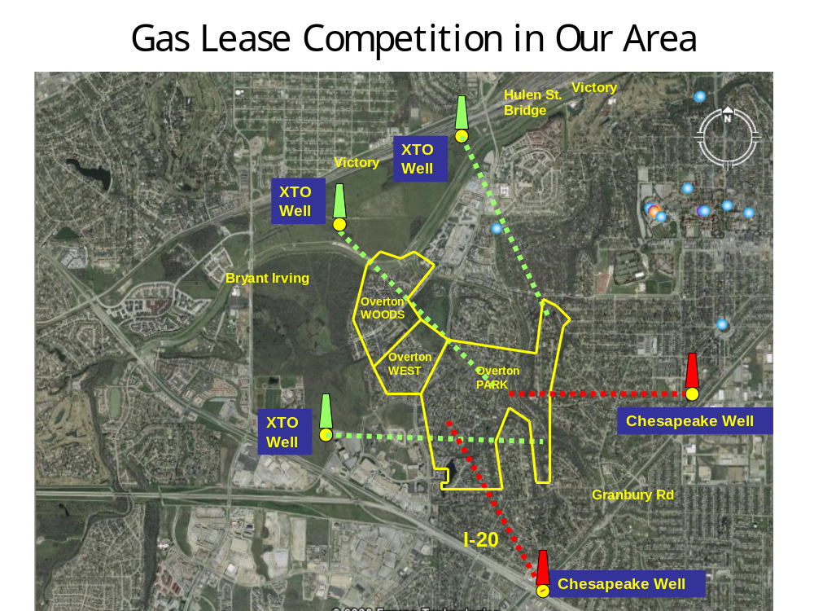

Neighborhood Association (NA)
Fort Worth, Texas 76109

Dear Neighbors, 8/18/2008

The Overton Park and Overton West Neighborhood Associations gas lease committees having concluded nine months of collaborative efforts and negotiations and are pleased to make the following announcement:

“The Overton Park and Overton West Neighborhood mineral owners should consider signing the NEW and revised XTO/Holland lease that has been developed for our Neighborhoods by XTO Energy Inc.”

Factors that were considered for the endorsement of these NEW terms are: (1) Timely Well Development, (2) Current Market Economics and (3) Overall Safety and Neighborhood Impact.

General Terms of the NEW XTO/Holland Lease are:

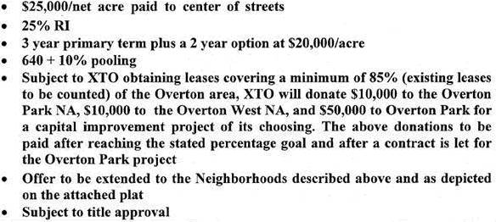

XTO is one of the largest independent producers of oil and gas and the third-largest overall producer of natural gas in the United States.
This lease will also be developed with the assistance of Vargas Energy, which is affiliated with Fort Worth's Edwards family.

We have been informed that the new XTO/Holland Lease packages will be mailed out shortly to all unsigned Overton Park & Overton West Mineral Owners as well as Mineral Owners in the areas surrounding Hildring Drive.

We hope this information is helpful to you as you make your gas lease decisions.
We would like to thank all who served on our joint gas lease committees for concluding this activity on our behalves.
Well done!

Please Note:
Our committee members are not gas experts or attorneys. This endorsement should in no way be construed as legal advice and should not be the only thing you consider in deciding whether to sign a gas lease. If you feel it necessary, you should seek individual legal counsel. You should not sign anything you have not read nor fully understand.

Sincerely,
/s/ - Bob Dellamura – Overton Park NA President
/s/ - Troy Tuomey – Overton West NA President

